Shire Amateur Photographers’ Society
‘Our aim is not to compete against each other – rather, to learn from each other’
_____________________________________________________________________________________________________________________________________________________________________________________________________________________________________________________________________________

Greg Ford 0415 412 244 Website: https://sutherlandshirephotography.com.au/photographic-society-2/ Email: gfphoto@optusnet.com.au



S.A.P.S. (Shire Amateur Photographers’ Society) Shire Amateur Photographers’ Society (SAPS)
https://www.flickr.com/groups/saps/pool/ https://www.facebook.com/groups/shireAmateur/

NEWSLETTER No 283 (12-09-2026)
__________________________________________________________________________________________________________________________________________________________________________________________________________________________________________________________________________________________________________________________________________________________

Hi everybody,

Well, July came and went, and I don’t remember doing much except lying around feeling a bit under the weather in Brisbane.
Time to move on … Lots happening with two trips away, one being the ‘King of the Ranges Festival’ at Murrurundi (nth western NSW) at the end of September, and the other, ‘Norfolk Island’ trip, where 20 of the Photographic Society are spending a week, cameras in hand.
_____________________________________________________

 Upcoming NEW Workshops
(Start this coming Wed 16th September)

I have found that one of the biggest frustrations of photography, is that people don’t fully understand the range of elements that can influence good composition.
So, I’m starting a new workshop, which kicks off this Wednesday (16th September) at Sutherland Park, on the corner of The Grand Parade & Linden St’s, Sutherland.
The Workshops will be held on a Wednesday morning and will go for 1 ½ h (9.30 – 11am) every fortnight.
This will rotate with the Society Coffee Chat groups, which meet on the alternate Wednesdays.
Notice of location will be sent out as a message a few days prior. If the Wednesday is bad weather, then it will move to the Friday of that week.
IMPORTANT: I need people to message me that you’re coming, the day before, so if the weather is iffy, I can contact you and tell you what’s happening.

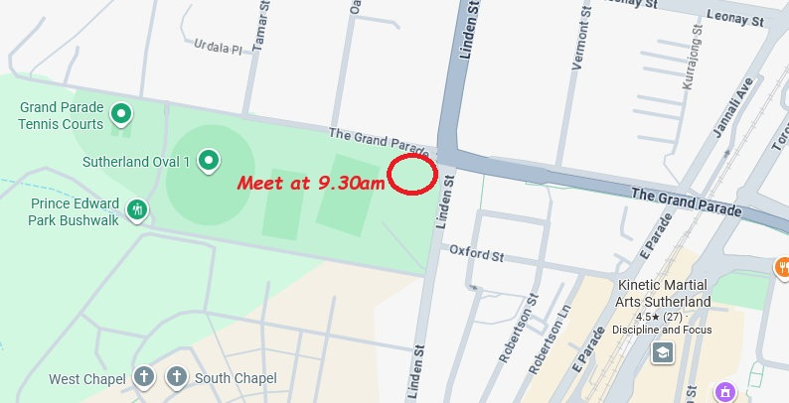

There is a starting list of Compositional Elements later in this Newsletter …

We turn up with a chair, cuppa and tripod in hand, to and sit and discuss what possible compositional opportunities that the location offers (brainstorm ideas…) before taking some shots.

Talk about the pros and cons, and combinations of different elements that are in front of us.
This is a Workshop, to learn, not to take the best shot ever.
To perhaps take the mundane, with the purpose of seeing what works or not, then use that knowledge to improve your understanding of composition, when you have and opportunity, with a better subject.

I hope you can join me, and share the thoughts, and company of other members for this new activity of the Society
_____________________________________________________

WEBINARS on Friday nights have changed …

I have found that after in illness in July, I need to change some of the things I do with Society, and one of those things is the frequency of the Webinars.
Most would not know, that I have been running webinars both on Monday nights & Friday nights, and the load & preparation can catch up with me.

So, the LAST Friday night webinar was Friday 11th September, and will now move to Monday nights only, starting Monday 14th September.
I canvased members at the last Society meeting, together with those on a Monday & Friday night webinars, and it was decided that Monday was generally the preferred night.
I hope that those that have joined me in the past on Fridays, will now be able to join us on Mondays at 7.30pm instead …

The Monday Webinar was a PD (Professional Development) group, and a lot of the things we covered will remain.

NEW FORMAT
With combining both webinars, I have decided to change to format slightly …
It will be more laid back, with more open discussion on anything photographic.
    - Bring up any question about photography (settings, techniques, how to …) etc
    - Lightroom & Photoshop questions & techniques, and ‘How To’
    - Discussing Professional photographer’s portfolios
    - Discussing pros and cons of images (as before)
    - You can also submit up to 10 images of your own, to talk about or discuss
    - Talking Composition …
    - Looking at older images where B&W was the only option
- What those photographers had to work with without colour

With the changes, comes a more regular webinars, and will be on most Monday nights (except when we are away), and you will be notified by message if that is the case …
_____________________________________________________

Photographic Society Moving Forward …

Since COVID era, many things have changed, and the people that are still interested in participating in our hobby group has reduced.

As we have moved forward over the past 4 years, it has been interesting to see how fast things have changed.

Our demographic is getting older, and interests change, and fade, and we find that older members change their habits and priorities. The motivation to get out and about starts to be lost (why the new Workshops on Composition), especially in the winter months, and even going out at night, becomes harder.
Private travel opportunities, for many, have become more appealing, taking many away from our shores, regularly.

But probably the most significant factor influencing interest and participation, is the technology advancements, especially with mobile phones and their camera capabilities.
Many of the younger generations (and some of us) don’t look at photography the way we used to, and don’t have the interest to learn more than what they can do with their phones.
Phone photography is what they know, and besides, they have it with them all the time, so why lumber all that gear around, they ask …
A regular comment is LOOK, this is what my phone took, and it looks fine (and I can send it to anybody, in an instant), and it’s all I need for the memories.
You still need to know composition of light & subject, that will make the difference.

Maybe, we are stuck in another era, but we love what we do (except for perhaps being a pack horse). Our approach to photography is a passion to be creative and gain satisfaction from our long-standing hobby.

Numbers interested in the Society have been dropping since COVID, from around 120 at meeting (at the
SUS Club), to around 40-50 a meeting in the last 18 months at Tradies.

So where do we go from here …
Like many, I’m getting older, and losing the energy that I once had ...

I think we perhaps need to restructure … Maybe use the friendships we have made to become a more socially orientated, and add other activities and subjects to look at, at the meetings.

The fifteen strong Steering Committee for the Photographic Society are meeting next week, to discuss how to move forward from now, and those discussions and outcomes will be then discussed with you, the members, at the next Society Meeting on the 2nd of October, at Tradies (7pm).

You are invited to share your ideas, either on the night, give me a call, or send me an email, and I look forward to your input.

We will move into 2027 with a new lease of life, to continue enjoying this hobby we love …

___________________________________________________

Next Society Meeting is Thursday 2nd October (7pm) Tradies

_____________________________________________________________________________

TASK for September ‘Images that tell a Story’
With this Task it is meant to use story within the photo. A prime compositional element, that you try to convey.
Send to me (gfphoto@optusnet.com.au) by Transfernow or WeTransfer by Wednesday 1st October.
________________________________________________

Composition Elements (a starting point)
It is about composing two main factors – ‘Composition of the Light’ and ‘Composition of the Subject’

Action
Aesthetically pleasing
Ambient light
Anchor points
Angles
Aperture
Architectural lines
Artistic arrangement
Aspect ratio
B&W vs colour
Backgrounds
Backlighting
Balance
Bend the rules
Biggest-Brightness-Sharpest
Blur
Bold statement
Bracketing
Catchlights
Clouds
Colour
Contrast
Contrasty subjects
Creativity
Cropping
D of F
Diagonals
Direction of movement
Distractions
Drag Photography
Drop Photography
Dynamic
Element Positions
Emotion (evoke)
Expose for the highlights
Exposure
Eye contracts (portraits)
Fill flash
Filters
Flare
Focal length (35mm)
Focal Point
Foreground-Midground-Background
Format Landscape/Portrait
Framing
Full Frame Composition
Golden Ratio Composition
High Key
Highlights
Hue
Human element
Imagination
ISO
Isolation
Leading lines
Leave it in or take it out
Lens compression
Lens distortion
Lens Field of View
Lines
Lighting takes many forms: Ambient, Contrasting, Backlit, Rim, Flare, Directional etc
Location (represent)
Long exposures
Look behind you
Low Key
Luck
Merging
Metering
Moment in Time
Moody
Natural environment
Negative space
Odd numbers
Off centre subject
Opportunity
Overexposure
Panning
Panning
Panoramic
Pattern
Perceived movement
Person (represent)
Perspective
Place (represent)
Placement of Subject
Point of Focus
Portraits – Moment in time
Portraits 35mm or longer
Pyramid Composition
Reflections
Repetition
Rim lighting
Rubbish
Rule of Thirds Composition
Separation
Shadows
Shape
Shutter Speed
Silhouette
Simplistic
Small subject – Big scene
Spontaneity
Stitching
Stop Motion Photography
Story (tell)
Straight horizon
Subject direction
Subject location options
Sun’s rays
Sweet spot
Symmetry
Symmetry Composition
Texture
Time Lapse Photography
Tonal variations
Uncluttered
Underexposure
Unique perspective
Vanishing point
Viewpoint
Weather
Zoom Photography
etc

Photographic Society Picnic Day …

Firstly, earmark in your calendar for the beginning of December, two activities.

Saturday the 5th December, as the date for the Society Xmas Picnic Day at Bundeena House, Bundeena, from 10am – 3pm.
All welcome friends and family, to share a social day amongst friends.
It is a picnic day (no BBQ facilities available), and it is BYO. It would be good if people could bring a sweet or something to share as well.
Tea and coffee facilities are available, and a good day is always had by all. Catch-up with this, our last activity for 2026, before Xmas break …

Our first Society Meeting for 2027, is on Thursday the 4th of February 2027.

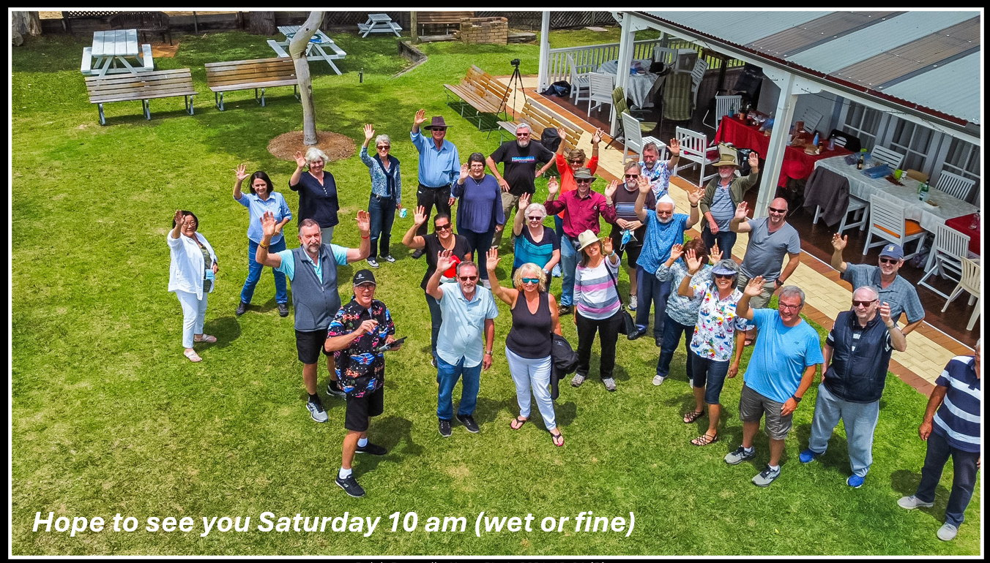
Bundeena House – Next to the Port Hacking River, Bundeena

_________________________________________

SAPS Membership & Meeting Attendance

Membership (2026) $35 (calendar year)
Club Meeting attendance $5 (per meeting)

Outings and Trips Away
The Photographic Society does NOT run its own activities like trips away or outings.
Instead, when I (Greg Ford) decide to go on my own photographic trip away or outing, I offer an open invitation to any ‘Shire Amateur Photographers’ Society’ member to join me if you’re interested.
You join me accepting that you are doing so at your own responsibility, and risk.

