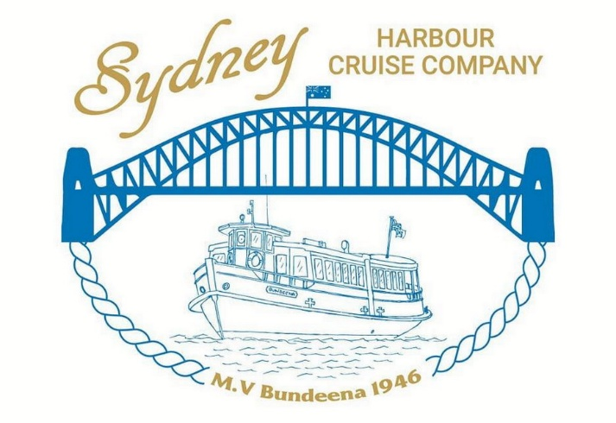
Special Photographic Society Opportunity
Outing Saturday 21st March
On Saturday 21st March our group has the opportunity for a trip on the Harbour on the vessel ‘Bundeena’ to photograph 20 Navy ships entering the Harbour for the 125year of the Royal Australian Navy ‘Fleet Review’.
The Navy ships enter the Harbour from 7.30am and we will be off Bradley’s Head to greet them.
We will be departing No.9 King Street Wharf at 6.30am and return at 10am. Train info to go in will follow …
The ticket price is $116.50 which now includes a light breakfast of muffins & Croissants. Tea, coffee or orange juice available to buy.
You can now book and buy your own ticket but you must message me (Greg 0415 412 244) when you have purchased it so I know who is coming …

Here is the info to buy your tickets (as I already have …)
This type of opportunity does not come around often and is certainly NOT worth missing …
Website to buy tickets: www.sydneyharbourcruisecompany.com.au
- Scroll down to 

