Shire Amateur Photographers’ Society
‘Our aim is not to compete against each other – rather, to learn from each other’
_____________________________________________________________________________________________________________________________________________________________________________________________________________________________________________________________________________

Greg Ford 0415 412 244 Website: https://sutherlandshirephotography.com.au/photographic-society-2/ Email: gfphoto@optusnet.com.au



S.A.P.S. (Shire Amateur Photographers’ Society) Shire Amateur Photographers’ Society (SAPS)
https://www.flickr.com/groups/saps/pool/ https://www.facebook.com/groups/shireAmateur/

NEWSLETTER No 279 (28/11/2025)
__________________________________________________________________________________________________________________________________________________________________________________________________________________________________________________________________________________________________________________________________________________________

Hi everybody,

Firstly, earmark in your calendar for the beginning of December, two activities.

Thursday 4th for the last Photographic Society Meeting for the year at Tradies, Gymea at 7pm.

Then Saturday the 6th December, as the date for the Society Xmas Picnic Day at Bundeena House, Bundeena, from 10am – 3pm.
All welcome friends and family, to share a social day amongst friends.
It is now a picnic day rather than barbecue, and it is BYO. It would be good if people could bring a sweet or something to share as well.
Tea and coffee facilities are available, and a good day is always had by all. Catch-up before Xmas break …

This is the last event for the society for 2025 although there will be some outings promoted before our first Society Meeting for 2026, which is on Thursday the 5th of February 2026.

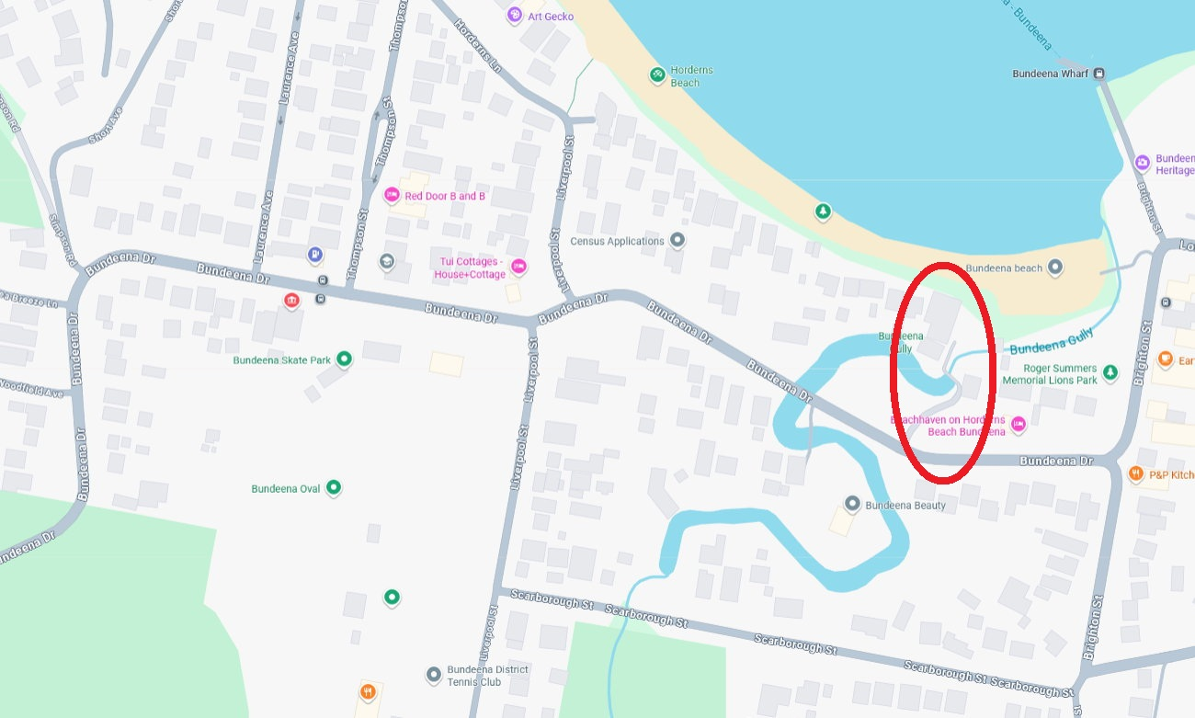
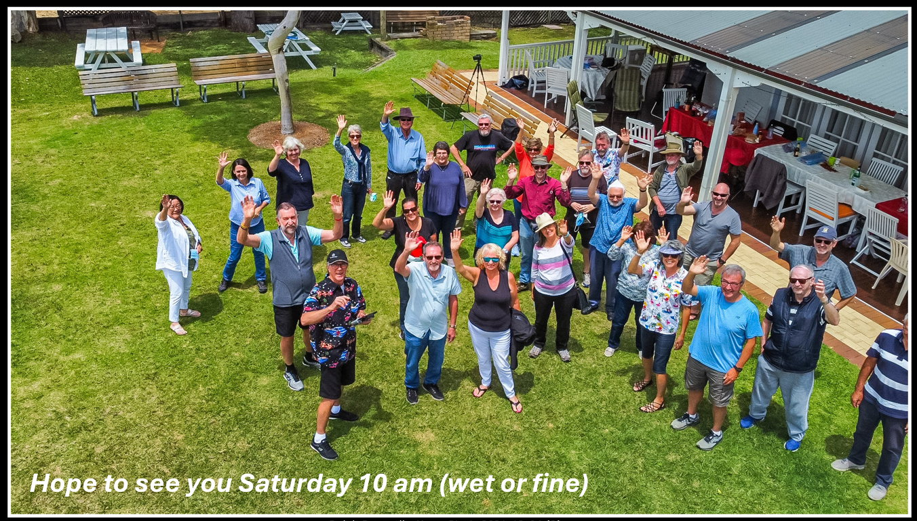

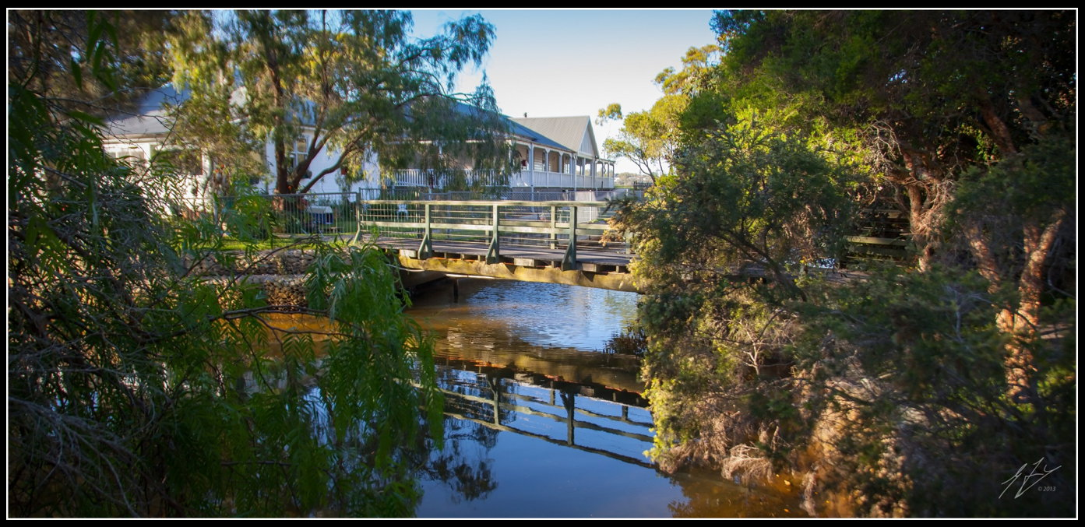

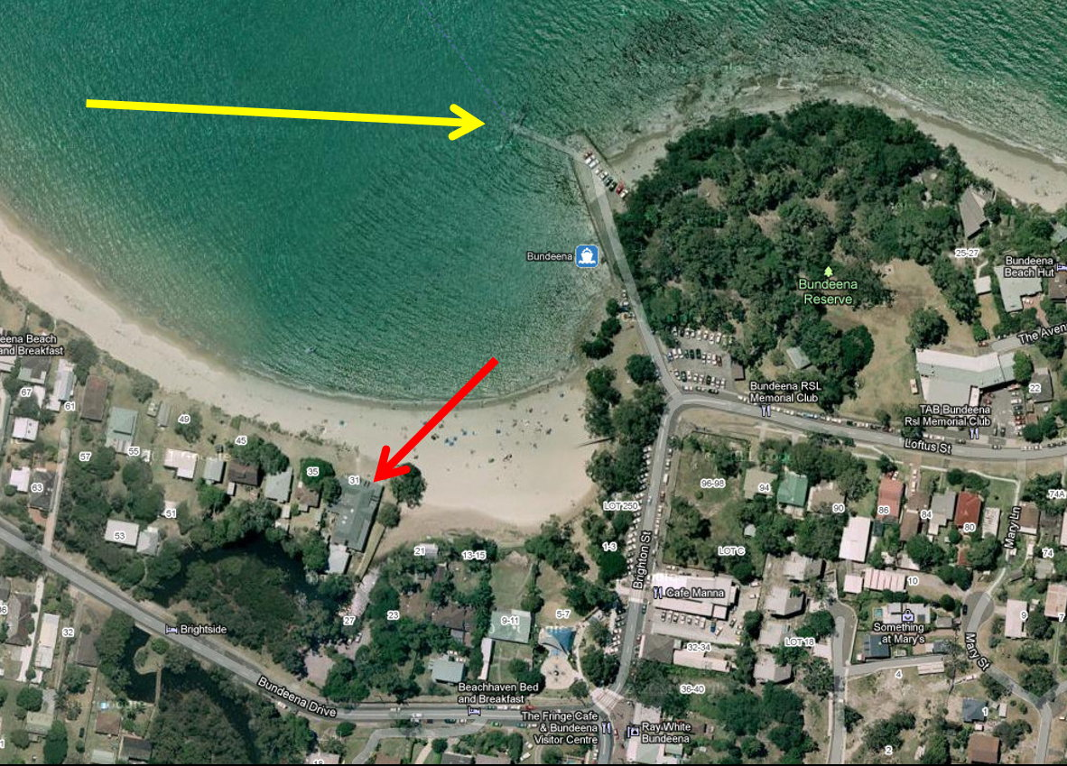
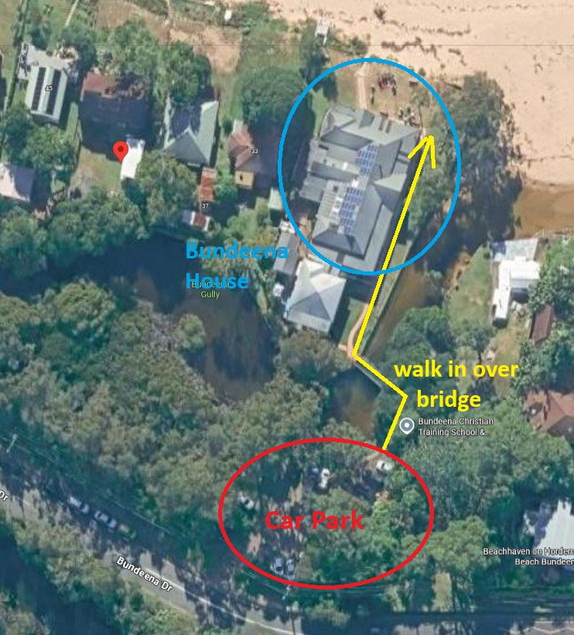

If you’re an old member, or a new one, come along and share this social day out, and make some new friendships and pick-up on some old ones …

Hope you can come next SATURDAY 6th December, Greg

____________________________________________________________

 Society Members trip Away to Thredbo in Spring …

To those that attended Thredbo village (Kiama Ski Lodge) trip away from 9th – 14th November, thank you for your support your keenness and your friendships over the 4 days. We had plenty of experiences, from 15 degrees one day, to -3 degrees on another. ALSO, snow did arrive on our trip all 5 inches of it.
We woke to a winter wonderland (Thredbo village) if only for a day.
We visited many places during our 4 days at the Lodge including Charlottes pass, Perisher Valley, Smiggin Holes, Bullocks Flat, Gutgher, Dead Horse Gap and some of the historic Geehi Flats cabins.

Considering the weather, we walked in several locations, through varied terrain including Thredbo River track, Cascades trail, Charlotte’s Pass walks and top of Snow Gums chairlift (Thredbo).
Was not without some challenges like when we returned to Thredbo from Geehi Flats, the road at the top of Dead Horse Gap became a little skittish with the road snow and ice crackling under the tires. For most low gear and or four-wheel drive was the way to go going back to the Thredbo Village.
The social aspect of the trip was enhanced, with some of the members volunteering to prepare meals for everybody, and that was a great success and well appreciated. Even lunch time did not happen without some warm soup, and most days, Sausages on the Barbie (thanks Paul).

In all for the 17 people that attended, it was a great experience and one that will stay in our minds for a long time.

Thanks again for everybody that attended, and joined in for not only the photography, but a great social trip with friends.

____________________________________________________________

Photography is Changing …

Photography is changing not only for newcomers to the hobby, but also for the purists like most of us that have grown up moving from black and white to colour film and digital DSLRs to mirrorless.
Two things stand out, that is changing the way we capture and manipulate our photographic records of events, holidays, celebrations and the interests.
- Firstly, is the phone technology producing more and more unbelievable results from such a small package. How do those little lenses capture what we see, so well, and how can the exposure in so many cases have a better outcome than our dedicated cameras. Hey if you want to pixel peep phone images, they still have a long way to go, but they are catching up so fast, that it’s only a matter of time, before they will be our preferred option.
- Secondly, the Ai revolution is advancing so quickly that there is barely time to learn features of programs before they are superseded.

It is for this reason that in the new year with the support of members of the Society, we will have a dedicated section at meetings devoted to learning the opportunities that phones now give us on a day to day basis. It’s an approach that I’m sure, will be appreciated by all, and with it comes a renewed motivation for our hobby …

_______________________________________________________________

2021-2022 eAlbum

The 2021-2022 eAlbum is all but finished, and although catching up with these albums due to Covid has been a challenge, I appreciate the interest and the submissions that have come in for this latest album. Over 200 images have been added to the eAlbum, and it’s only down to the book committee to make a decision on the image that will hold prior to place as the book cover.

As soon as the decision for the cover has been made, the finished eAlbum will be sent by ‘transfernow’ to everybody that contributed images.
As well, if you did not get a chance to put in images this time, but would still like to receive the 2021-2022 eAlbum, just let me know by email, and I will send it through to you …

TASK for November: ‘Perceived Movement’

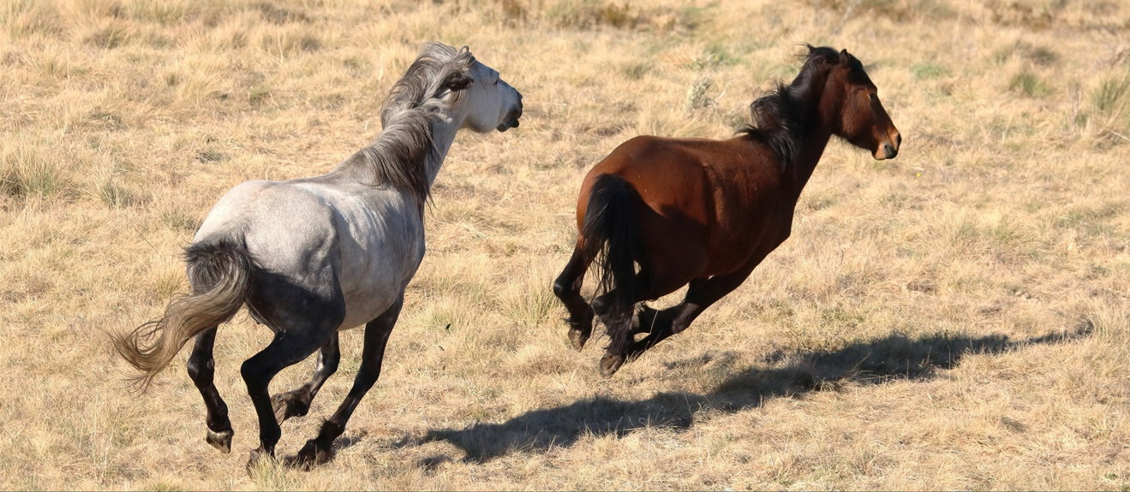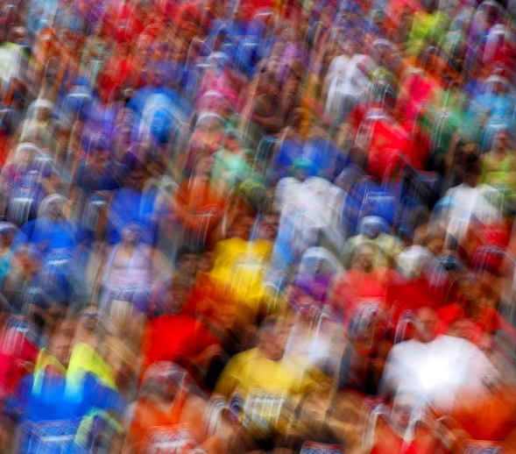

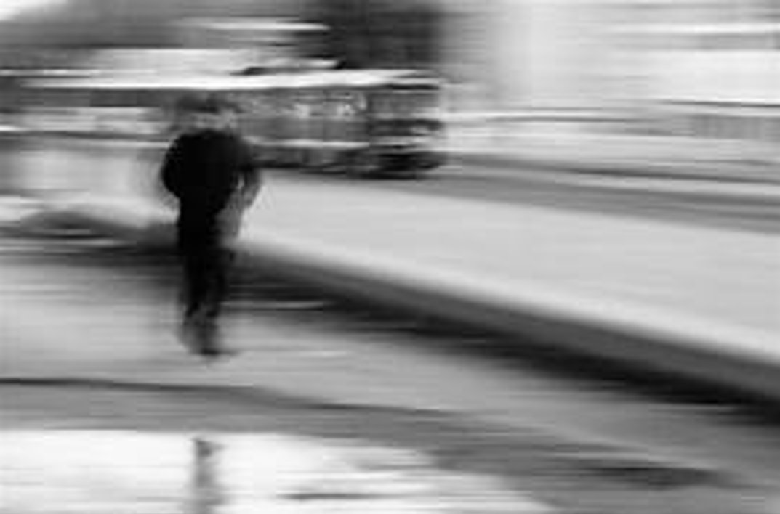

Send me up to 5 x images for the 4th December meeting by Tuesday night the 2nd December by ‘transfernow’ or ‘we transfer’ to me at gfphoto@optusnet.com.au.

____________________________________________________________

2026 Membership

Our Membership has been gradually declining since the COVID period, due to a number of issues, mainly due to demographic of the membership, the advent of phone technology, our interests changing as we get older, ill health, having those holidays that we have promised ourselves for so long, just getting out at night, and the younger generations having other life interests, where their phones are adequate for their photographic interests (re social media).

For the Photographic Society to continue, we have needed to change its direction, introducing more socially minded activities like our Coffee Chat groups, our Walking group on Sunday afternoons at Wonorora, Tag along trips away (in 2025 – Man from Snowy River Festival, Corryong, Vic and our Trip to the Snowy Mountains - Thredbo recently.

It is therefore important to keep up Social activities and interesting topics incl. phone technology.

I hope you will continue with our Photographic Society membership for 2026 by filling out the Membership Form below, and emailing it to me at gfphoto@optusnet.com.au, or by bringing it to the next meeting.

Many members have mentioned is there another way of paying for meeting attendance …

With the cashless society now really taking hold, I am therefore introducing a membership option that might suit some of you.

It incorporates the yearly membership ($35), and the $5 meeting attendance for the 10 meeting for the year. This will have a discounted cost of $70 ($85)

Please select the appropriate membership you require on the Membership Form, thank you.

__________________________________________________________________

2026 Membership Form (over page) …

Shire Amateur Photographers’ Society

2026 Membership

Name

SELECT  OPTION | $35  (Membership) |  |  | $70  (Membership & Meeting attendances) |  |  | cash | EFT
Suburb

Email

Mobile

Office use … |  | Joined | Mailchimp |  |  |  | Name tag

NOTE: NEW Bank deposit details … Don’t use old details

Bank: Westpac
Account Name: Gregory Ford
Account Num: 611205
BSB: 732 -112
Reference: your surname or last 3 digits of mobile number
Amount: $35 p.p. (Membership) $70 p.p. (Membership & Meeting Attendances)

Please fill out this form and email back to gfphoto@optusnet.com.au then message me to let me know you have made payment. I will message you confirming receipt of payment, thank you

________________________________________________

SAPS Membership & Meeting Attendance

Membership (2026) $35 (calendar year)
Club Meeting attendance $5 (per meeting) 10 x meetings year

Outings and Trips Away
The Photographic Society does NOT run its own activities like trips away or outings.
Instead, when I (Greg Ford) decide to go on my own photographic trip away or outing, I offer an open invitation to any ‘Shire Amateur Photographers’ Society’ member to join me if you’re interested.
You join me accepting that you are doing so at your own responsibility, and risk.

