Shire Amateur Photographers’ Society
‘Our aim is not to compete against each other – rather, to learn from each other’
_____________________________________________________________________________________________________________________________________________________________________________________________________________________________________________________________________________

Greg Ford 0415 412 244 Website: https://sutherlandshirephotography.com.au/photographic-society-2/ Email: gfphoto@optusnet.com.au



S.A.P.S. (Shire Amateur Photographers’ Society) Shire Amateur Photographers’ Society (SAPS)
https://www.flickr.com/groups/saps/pool/ https://www.facebook.com/groups/shireAmateur/

NEWSLETTER No 270 (18/07/2024)
__________________________________________________________________________________________________________________________________________________________________________________________________________________________________________________________________________________________________________________________________________________________

Hi everybody,

NOW we are in winter … It’s certainly been cold some mornings.
Hope all are well and enjoying their photography…
I have been using the winter period to do a lot of file sorting and especially enhancing my images – I’m so far behind. I just keep taking photos and never catch up. Am I going to stop – NEVER…

We all have to have interests that don’t require physical exertion, because we don’t have the energy that we used to have.
Computers, and in particular (for me) enjoying viewing, enhancing and creating images from our photography efforts, is an important part of filling the passive times that our bodies require.

We must appreciate that the outcomes we achieve from our photography is a very personal thing, and if you are satisfied with these outcomes, then nothing else matters. Your hobby has achieved purpose …

The July meeting saw an increase in numbers attending, in part, probably being the first meeting in a while when rain was not a main factor in deciding.
The changes to the content in the meetings has also been a factor, with members expressing their interest in the variety.

The past month or so has been a bit light on outings, with changing my activities, to slow down a bit … Trips to the mid-north coast and Jervis Bay has still given some people the opportunity to get out there with like-minded people, to enjoy their company and our beautiful country.

 Next Outing – Wildlife Photographer of the year exhibition+

Wed 24th July (Maritime Museum)
Meeting at Sutherland Station on Wed morning to catch the 9.08am train to Central Railway, then the light rail to Pyrmont (Murray St Station) then return …
Entry to the Exhibition is $15 (concession)
Poor weather will not affect this outing …
You must message or ring me to tell me you are interested in going 0415 412 244 (Greg)
___________________________________________________

TASK to Photograph for the month of July

‘High Key’
What am I talking about …
Where the majority of the image is bright exposure or light tones (looks like it’s overexposed – maybe it is)

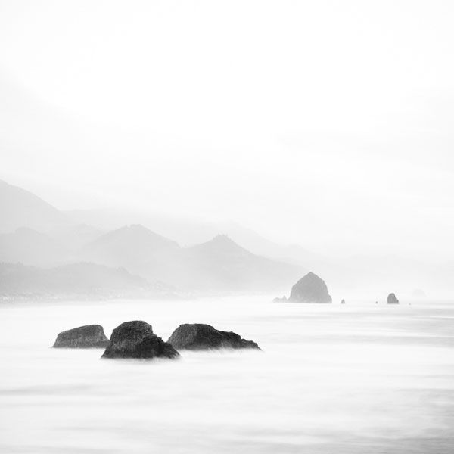

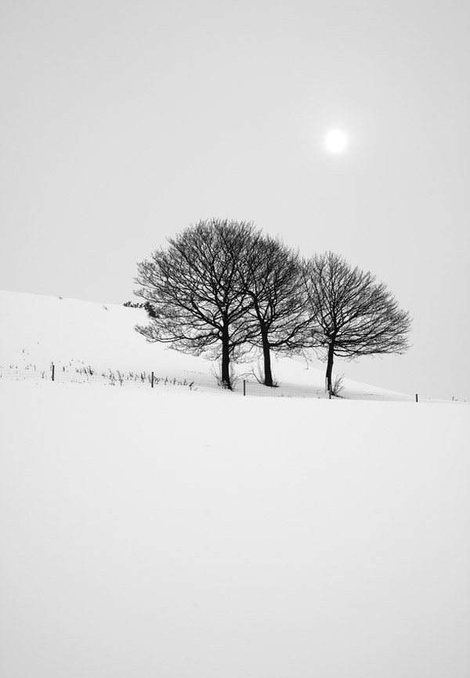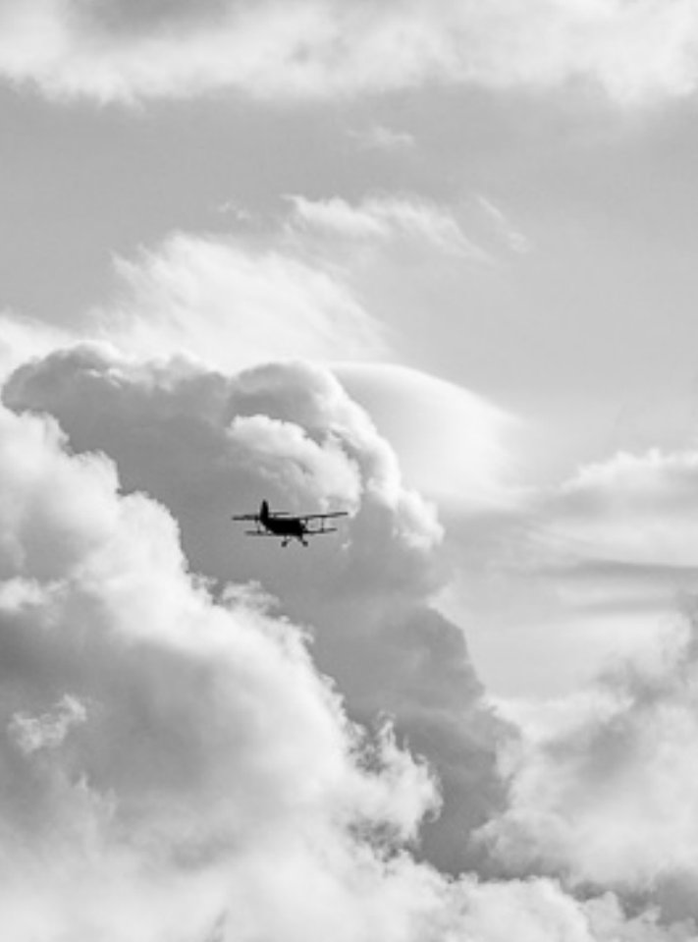

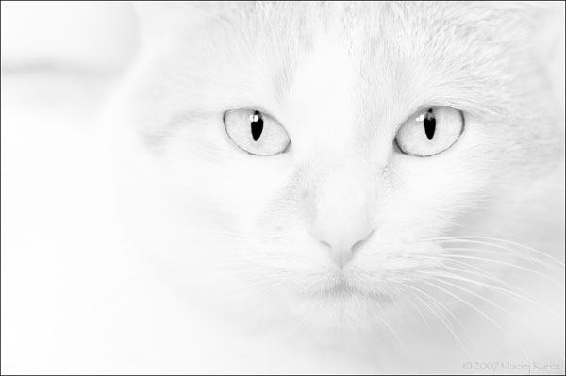

Transfer up to 5 images to Greg by WeTransfer (or email) to gfphoto@optusnet.com.au by Tuesday 30th July …

NEXT Society Meeting at Tradies Thursday 1st August (7pm)

Note:
The Society does not have a group booking now for the restaurant since the new one opened. If you go for a meal, maybe look for other members to sit with …

************************************************************************************

Society Member Request …

Hi Greg

HOLIDAY PHOTOS OF ANCIENT SITES. My daughter Jacqueline works for the Education Dept & has received the following request from a colleague. HSIE are trying to put together a photo library of ancient sites around the world that can be used in our programming to allow us to avoid any copyright issues when developing school resources. They don’t have to be professional. If you would like to donate to the library, please label where & when photo/video was taken, & your name to
Hsie@det.nsw.edu.au
HSIE Photo Library-photos & videos of ancient sites
Thanks Jenelle McWilliam
Request for Images for August Society Meeting

Eddy made a suggestion that we should collect a few images from members, that mean the most to them of the many thousands they have taken, so between now and end of July I would like you to pick 4 images to send in that mean the most to you … Title them ‘My Moments in Time’.
Transfer up to 2 images to Greg by WeTransfer (or email) to gfphoto@optusnet.com.au by Tuesday 30th July …

____________________________________________________________________________________

Society Memberships are now overdue for 2024

Just fill out the Membership form at the end of this newsletter and email it to gfphoto@optusnet.com.au
I will confirm your new membership for 2024 when your $30 payment is received.
Alternatively, fill out and bring to the next Society meeting at Tradies at Gymea (4th July).

There are a number of people that are participating in activities that have not yet joined the Society for 2024. If not sure of your membership, check with the girls on our desk at our Society meeting …

Costs associated with running the Society add up, and they include Tradies room hire for the year of over $2,000 so we need your memberships ..

Thank you for your ongoing support, Greg

____________________________________________________________________________________

Messages sent on Fridays to ALL Society members letting you know of upcoming activities …

If you do not receive a message (Society UPDATE) usually on a Friday, or you do not receive a Newsletter h (mid-month) send me a message, and I will follow it up …

____________________________________________________________________________________

Society Photography Webinars (7.30pm)

If you would like to be a part of the Society Photography Workshop Webinar on a Friday night (7.30pm), just login via the link below, and join other people wanting to extend our knowledge of our chosen hobby.

You can login just to listen, or add your comments or suggestions as you wish

Note: There is 3 webinars a month, but no webinar on the Friday of the week of the Society meeting.

Link to access ALL Webinars …
https://us02web.zoom.us/j/88993683116?pwd=aXhSMzQ5RWhaTHpPQzlzTTNORlhSQT09
Alternatively use: Meeting I.D. 889 9368 3116
Password 040331
For further information just message or give Greg a ring (0415 412 244)

Shire Amateur Photographers’ Society

2024 Membership ($30)

Name |  |  |  | Date paid |  | Cash |  | EFT
Address

Email

Mobile

Office use … | Joined | Mailchimp | Email |  | Message |  | Name tag

NOTE: NEW Bank deposit details …

Bank: Westpac
Account Name: Gregory Ford
Account Number: 611205
BSB: 732-112
Reference: your surname or last 3 digits of mobile number
Amount: $30 per person

Please fill out this form and email back to gfphoto@optusnet.com.au then message me to let me know you have made payment. I will message you confirming receipt of payment, thank you

________________________________________________

SAPS Membership & Meeting Attendance

- Membership (2024) $30 (calendar year)
- Club Meeting attendance $5 (you can attend 2 meetings before becoming a Member)

Outings and Trips Away
The Photographic Society does NOT run its own activities like trips away or outings.
Instead, when I (Greg Ford) decide to go on my own photographic trip away or outing, I offer an open invitation to any ‘Shire Amateur Photographers’ Society’ member to join me if you’re interested.
You join me accepting that you are doing so at your own responsibility, and risk.

_________________________________________________________________________________

